A SYNOPSIS OF MINI PROJEC

PROJECT TITLE

BLINKIT CLONE – A HYPERLOCAL GROCERY DELIVERY SYSTEM

Submitted In Partial
Fulfillment Of The Requirements For The Award Of The Degree Of

BACHELORS OF SCIENCE

IN
INFORMATION TECHNOLOGY

By

ROBIN SINGH (roll No- 22229521047)



MODERN INSTITUTE OF TECHNOLOGY DHALWALA
RISHIKESH

(2022 - 2025)

ABSTRACT

This project aims to develop a hyperlocal grocery delivery platform inspired by Blinkit. The system will allow users to browse nearby stores, order daily essentials, and receive them at their doorstep in minimal time. The application features a user-friendly interface, a secure checkout process, and real-time delivery updates. It also includes an admin panel for inventory management and order tracking. The platform will be built using modern web and mobile technologies and demonstrate the core functionalities of a quick-commerce system.
I

NTRODUCTION

With the rapid growth of e-commerce and the need for faster services, platforms like Blinkit have emerged as key players in the grocery delivery industry. This project seeks to simulate Blinkit’s model, delivering groceries in record time by connecting users to local vendors through a digital platform.

WHY THIS PROJECT?
In a world where time is a luxury, the demand for ultra-fast delivery services is booming. Blinkit has revolutionized grocery shopping by promising deliveries within minutes. Recreating such a system is both a technical challenge and an exciting opportunity to dive deep into real-world application development. This project allows us to blend modern technologies like real-time databases, APIs, and mobile-first design with the dynamics of user experience, logistics, and local commerce. It’s not just a project—it's a glimpse into the future of shopping
OBJECTIVES AND GOALS
- Develop a multi-user platform (Customer, Admin, Delivery).
- Implement real-time order tracking and inventory updates.
- Integrate payment gateway and notifications.
- Ensure scalability and performance.

TOOLS and PLATFORM
Software platforms:
1- Frontend: HTML , CSS
• Backend: PHP
• Database: RDBMS
• Version Control: Git & GitHub
• Deployment: Firebase / Heroku / Netlify
BLOCK DIAGRAMS OF PROJECT

- General block diagram
User → App Interface 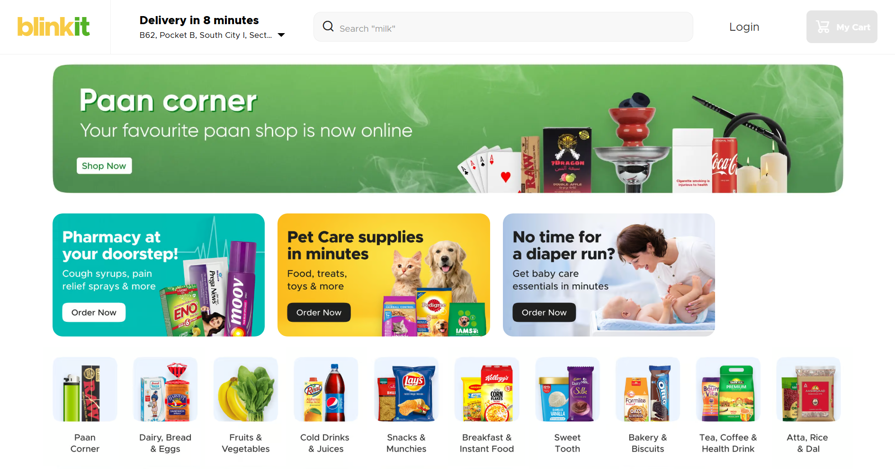 → Product Search
→ Cart
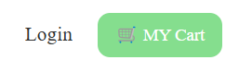

- APPLICATIONS:

This project has wide applications:
- Hyperlocal grocery delivery
- Medicine/Essentials delivery
- Quick e-commerce for daily needs
- Local store digitization

This project has enormous and useful applications:

Future of the project:

- Multi-vendor support
- Personalized notifications and offers
- Voice-based search
- TO provide employment

LITERATURE SURVEY:-

Blinkit – Company Overview and Case Study

REFERENCES:-

https://blinkit.com

CONCLUSION

This project delivers a practical solution inspired by modern e-commerce giants like Blinkit. It demonstrates how technology can simplify everyday tasks and enable fast, efficient service delivery. By completing this project, we gained hands-on experience in full-stack development, real-time databases, API integration, and user-centric design. The Blinkit Clone not only showcases technical capabilities but also encourages innovation in the domain of hyperlocal logistics and digital commerce.

